**ASSIGNMENT-6**

1. Write a C program to find the largest element using Dynamic Memory Allocation.

Code:

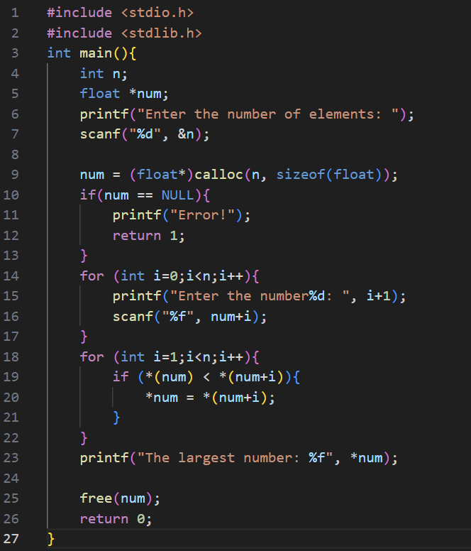

Output:

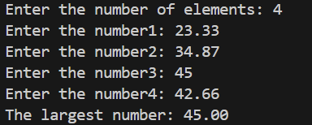

1. Write a C program to read a one-dimensional array, print sum of all elements along with inputted array elements using Dynamic Memory Allocation.

CODE:

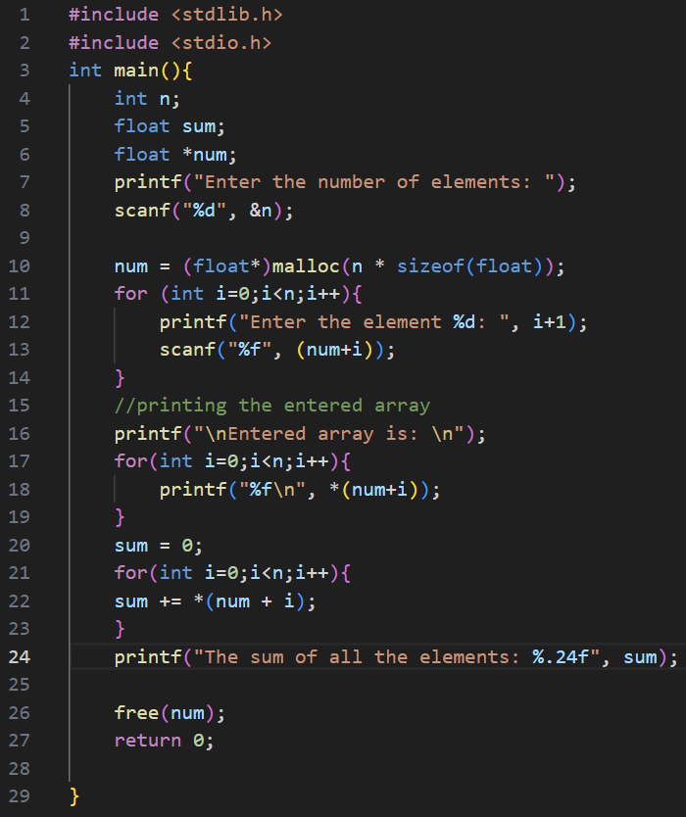

Output:

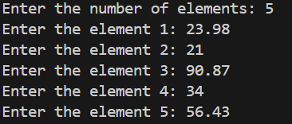

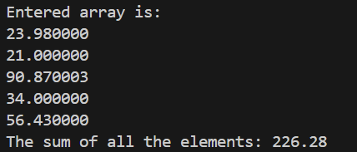

1. Write a C program to read and print the student details using structure and Dynamic Memory.

Code:

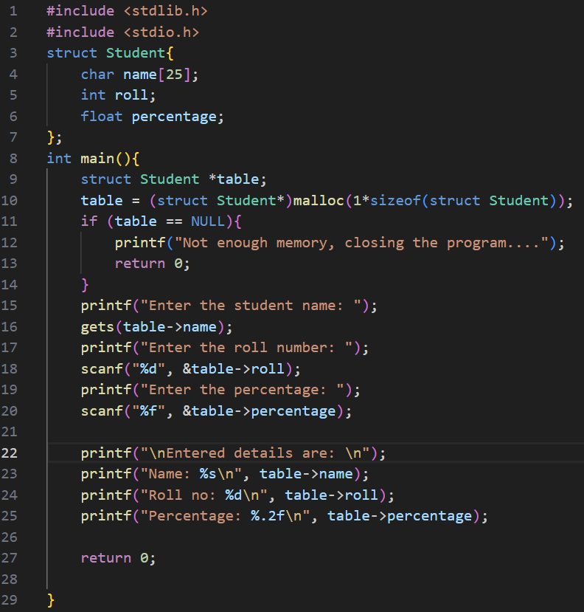

Output:

